SVD GDC(W) NIDADAVOLE
DEPARTMENT OF ZOOLOGY
DEPARTMENTAL BEST PRACTICES

Name of the Institution: SVD GDC(W) NIDADAVOLE
Department: ZOOLOGY
ACTIVITY NAME:Blood Group Departmental activity
Date: 21/10/2025
Prepared by: V.SATYNARAYANA,LECTURER IN ZOOLOGY

Introduction

The Blood Group Department plays a crucial role in identifying, classifying, and maintaining accurate records of individuals' blood groups, which is essential for safe blood transfusions, medical treatments, and emergency healthcare services. To ensure accuracy, safety, and efficiency, the department follows a set of best practices in all its operations.

Objectives

To ensure precise blood typing and cross-matching.

To maintain strict quality control and safety standards.

To create awareness about blood donation and its importance.

To promote ethical and professional laboratory practices.

Best Practices Implemented

1. Accurate Sample Collection and Labeling

Samples are collected using sterile equipment.

Each sample is labeled immediately with patient details and a unique ID to avoid mix-ups.

2. Standard Testing Procedures

Blood grouping is carried out using both forward and reverse typing methods.

All reagents are checked for expiry and quality before use.

3. Quality Assurance and Control

Daily calibration of testing equipment is performed.

Internal and external quality control programs are followed regularly.

4. Data Management

Digital records are maintained for all test results to ensure traceability.

Confidentiality of patient information is strictly maintained.

5. Staff Training and Competency

Regular workshops and refresher courses are conducted for laboratory staff.

Hands-on training is provided for handling new technologies and techniques.

6. Safety and Hygiene Protocols

Strict adherence to biosafety measures such as wearing gloves, lab coats, and masks.

Proper disposal of biohazardous waste as per safety regulations.

7. Awareness and Outreach Activities

Organization of blood donation camps and awareness programs.

Educating students and the public on the importance of knowing one’s blood group.

8.Emergency Readiness

Quick response protocols in place for emergency transfusion requests.

Collaboration with hospitals and blood banks for urgent supply needs.

Outcomes

Improved accuracy in blood typing and record management.

Increased awareness and participation in blood donation drives.

Enhanced staff competency and safety compliance.

Strengthened community linkage through outreach programs.

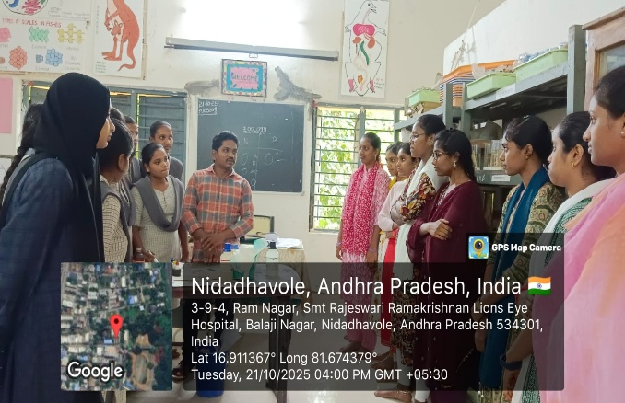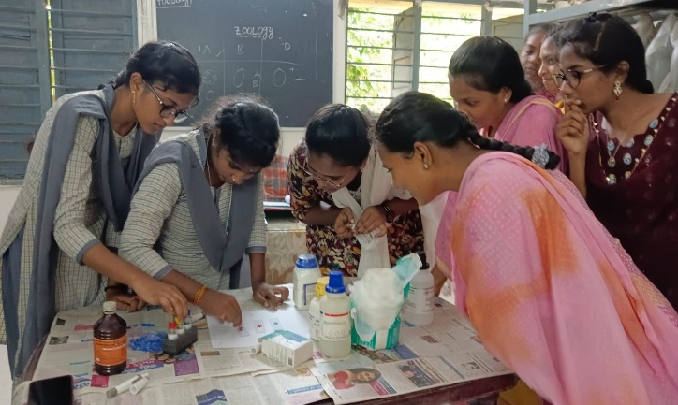
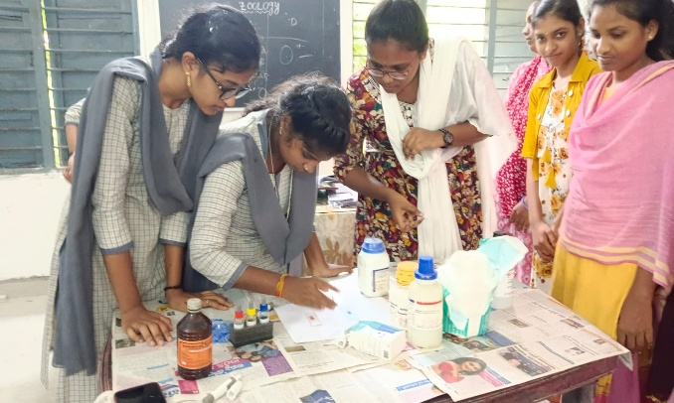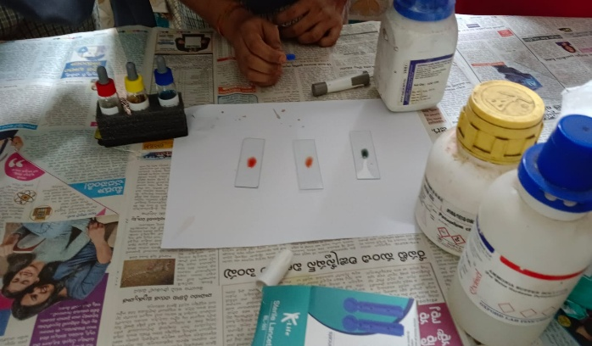
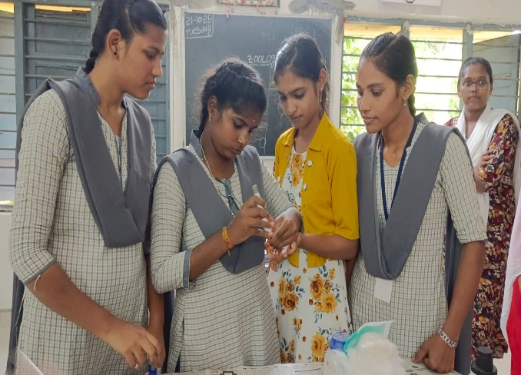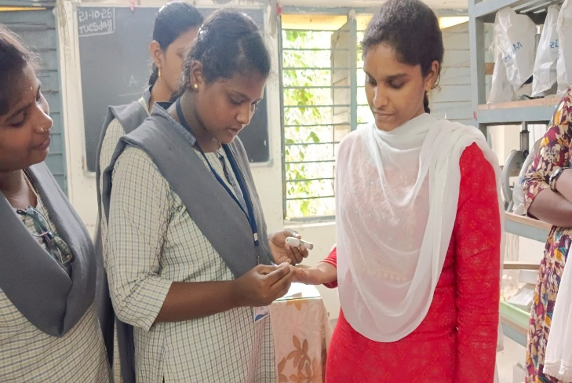
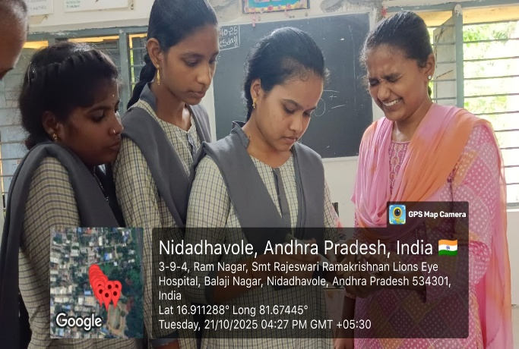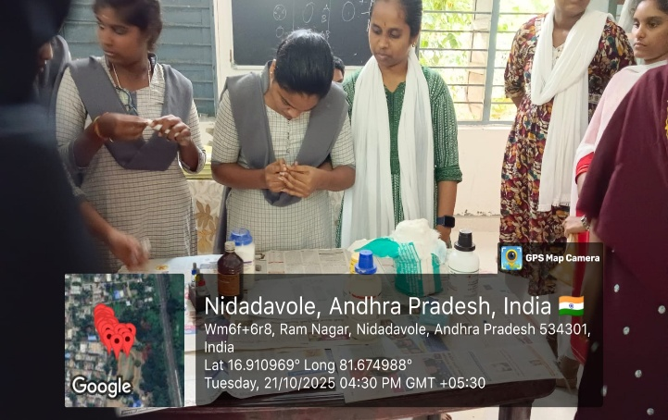

S.NO | NAME | GROUP | BLOOD GROUP
1 | B.NAVYA SRI | 2nd ZOOLOGY | A+
2 | D.SAILAJA | 2nd ZOOLOGY | A+
3 | E.DIVY NAGA LAKSHMI | 2nd ZOOLOGY | B+
4 | E.ALEKHYA | 2nd ZOOLOGY | B-
5 | G.NIHARIKA | 2nd ZOOLOGY | O-
6 | J.MOUNIKA | 2nd ZOOLOGY | B-
7 | K.ARUNA | 2nd ZOOLOGY | O+
8 | K.PALLAVI | 2nd ZOOLOGY | O+
9 | K.DURGA BHAVANI | 2nd ZOOLOGY | B+
10 | M.JAYARANI | 2nd ZOOLOGY | O-
11 | N.NAGALAKSHMI | 2nd ZOOLOGY | A-
12 | P.JAYADEVI | 2nd ZOOLOGY | O+
13 | P.TEJAPOOJITHA | 2nd ZOOLOGY | B-
14 | SK.SHABINA | 2nd ZOOLOGY | A+
15 | Y.SUDHISNA | 2nd ZOOLOGY | O+

S.NO | NAME | GROUP | BLOOD GROUP
1 | M.KRANTHI | 1st ZOOLOGY | B+
2 | M.ALEKHYA | 1st ZOOLOGY | AB+
3 | M.GLORY | 1st ZOOLOGY | B+
4 | U.MEGHANA | 1st ZOOLOGY | O-
5 | K.SARANYA | 1st ZOOLOGY | AB-
6 | K.SATWIKA | 1st ZOOLOGY | A+
7 | K.NAVAMALLIKA | 1st ZOOLOGY | AB-
8 | T.MALA SRI | 1st ZOOLOGY | A-
9 | K.GAYATHRI | 1st ZOOLOGY | A+
10 | SK.SHARMILA | 1st ZOOLOGY | A-
11 | CH.YESUKUMARI | 1st ZOOLOGY | A+
12 | K.OKTASATYAM | 1st ZOOLOGY | A-

Conclusion

The Blood Group Department continues to uphold excellence through its commitment to precision, safety, and service. By following these best practices, the department contributes significantly to healthcare support and community well-being.

